Variable Bubble Point Problem in GPRS Black-Oil Model

Yaqing Fan
Jan 25th, 2006

The bubble point pressure is defined as the pressure at which the first bubble of gas evolves in an undersaturated oil while the pressure is decreasing (Fig 1. point B). In current GPRS, if the pressure is larger than the bubble point pressure, the gas-oil ratio is treated as constant (B—A). However, in fact, if sufficient gas is continuously supplied as the pressure is increased, the oil will remain saturated along the curve of from B to E. Similarly, if the pressure is decreased while the gas is removed continuously, the bubble point will be decreased along the curve from B to C. In a word, the bubble point pressure is related to the gas saturation.
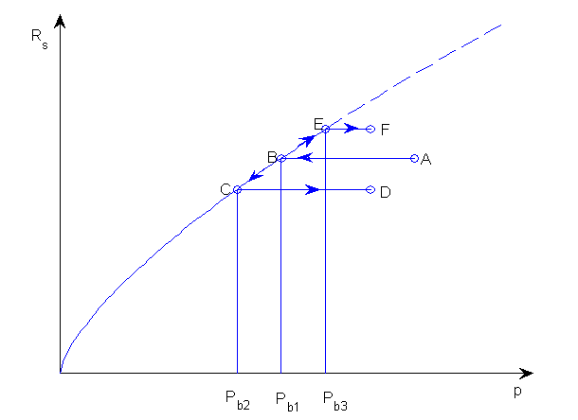
Fig 1. Changing bubble point with reversal of pressure changes
(from Petroleum Reservoir Simulation, Khalid Aziz)

Now let’s see a three phase case of black oil model and the plots of comparison between GPRS and Eclipse results. The case description is shown in the following table.

Table 1. Case-1 summary for modified SPE-1

 | Modified SPE-1 Case Description
Dimension | Grid: 10 x 10 x 3; each grid: dx=dy=1000 ft; dz=20ft
Permeability | k=kx=ky=kz in all layers; k=500md, 50md, 200md for 3 layers
Initial Condition | Sw=0.12; So=0.88; Sg=0.0; Pressure~4800psia
Producer | (10, 10, 1) ; BHP control 1000 psia
Injector | (1, 1, 1); BHP control 8000 psia

The comparison of GPRS and Eclipse results are shown below.
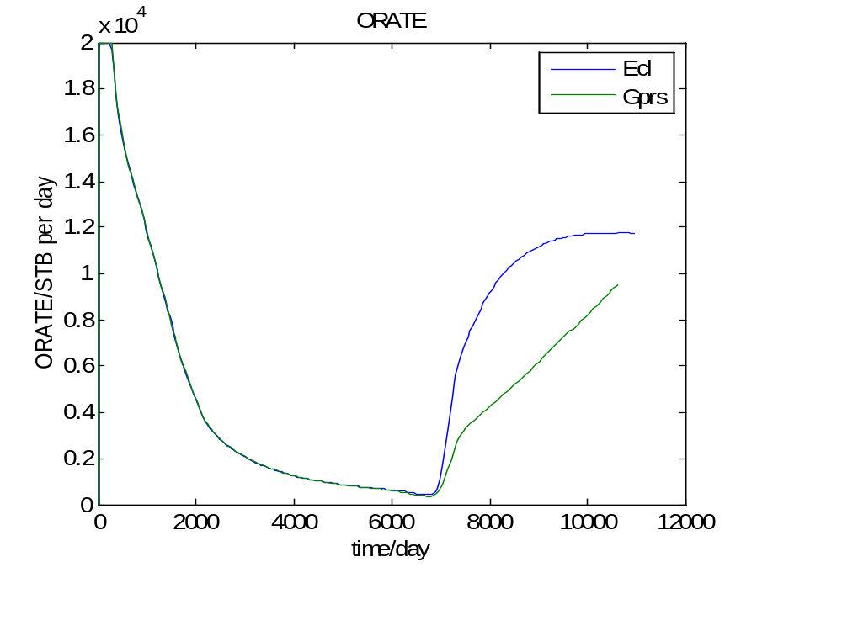
Fig 2(a). Comparison of oil rate for case-1
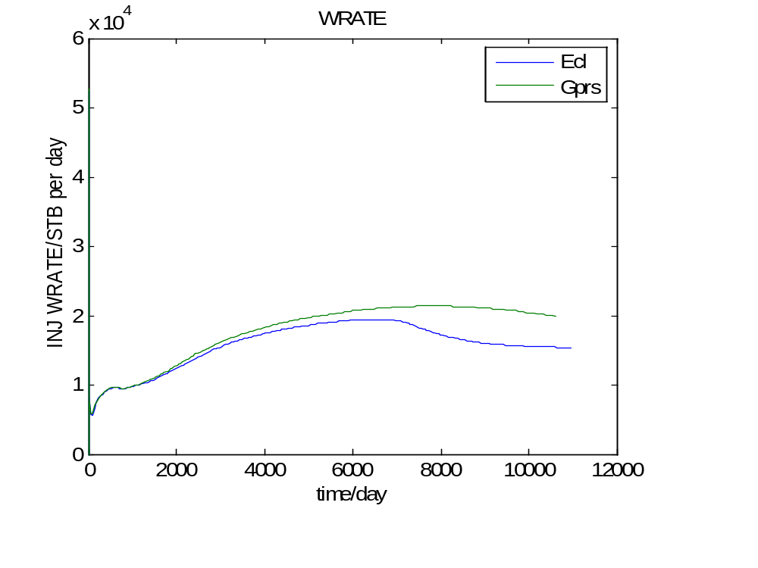
Fig 2(b). Comparison of injection water rate for case-1

Let’s consider a typical block in the center of the reservoir, whose coordinates are (5, 5, 1). Figure 3 shows the saturation history of this block over 30 years. Note that the gas saturation became negative after 6000 days. The pressure and bubble point pressure history of this block is shown in Fig 4.
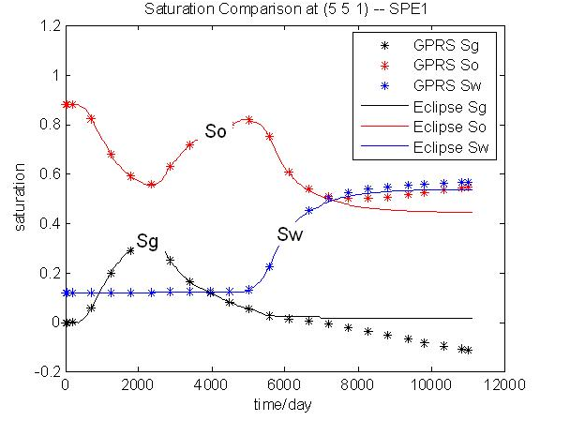
Fig 3. Saturation history of block (5, 5, 1) in case-1

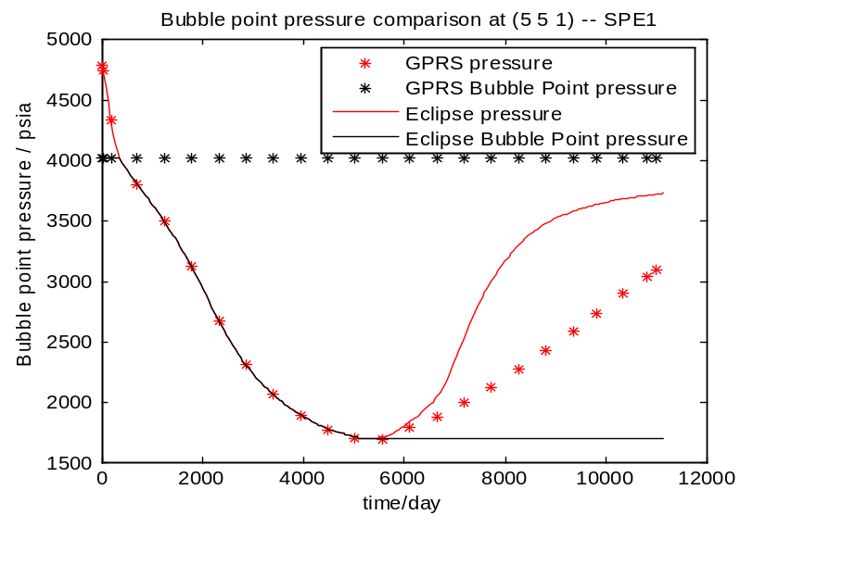
Fig 4. Pressure and bubble point pressure history of (5, 5, 1) in case-1
Obviously, after 4700 days, the block pressure in GPRS is lower than bubble point pressure, and the process follows A-B-C-B-A in Fig 1. During the process from C to B, since gas phase saturation is too small to provide enough gas to meet the increasing Rs, negative gas saturation came to exist.

However, in Eclipse, the block pressure is higher than bubble point pressure, and the process follows A-B-C-D in Fig 1. In fact, this process is correct.

